**Week 4 - Homework 2**



**SQL QUERY**

SELECT * FROM customer WHERE store_id = 2





**SQL QUERY**

INSERT INTO customer VALUES

(600, 1, 'JOHN',' SMITH', 'JOHNSMITH@HOTMAIL.COM', 606,'1',TIME(),TIME()),

(601, 2, 'JOHNNY','DAHYA', 'JOHNYDAHYA@HOTMAIL.COM', 607,'1',TIME(),TIME()),

(602, 1, 'TINA', 'WILSON', 'TINAWILSON@HOTMAIL.COM', 608,'1',TIME(),TIME())





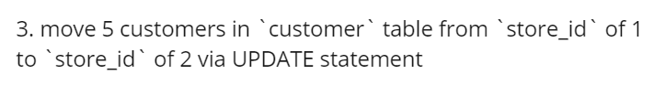

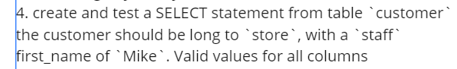

**SQL QUERY**

SELECT customer.*,staff.first_name,staff.last_name FROM customer JOIN staff

WHERE customer.store_id=staff.store_id AND staff.first_name = 'Mike'

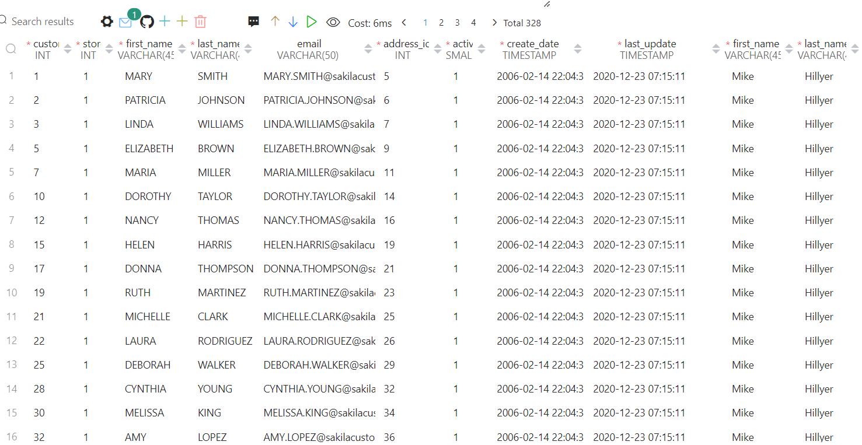



**SQL QUERY**

INSERT INTO store VALUES (3,3,3,TIME())

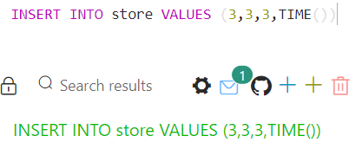

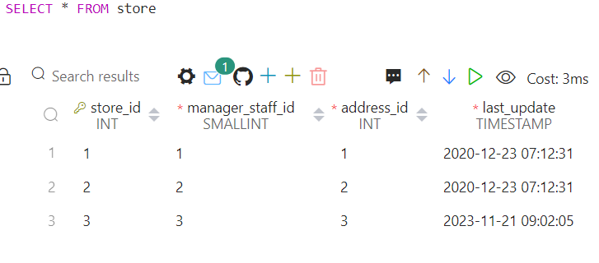

**SQL QUERY**

UPDATE staff SET store_id = 3, last_update = TIME() WHERE first_name = 'Jon'

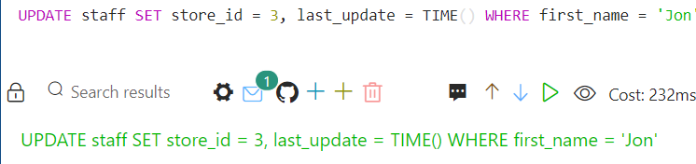



**SQL QUERY**

INSERT INTO customer VALUES

(603,3,'GINA','SHELDON','GINA.SHELDON@sakilacustomer.org',609,'1',TIME(),TIME()),

(604,3,'TINA','CHARLES','TINA.CHARLES@sakilacustomer.org',610,'1',TIME(),TIME()),

[(605,3,'DIANA','WILSON','DIANA.WILSON@sakilacustomer.org',611,'1',TIME(),TIME())](mailto:(605,3,'DIANA','WILSON','DIANA.WILSON@sakilacustomer.org',611,'1',TIME(),TIME()))

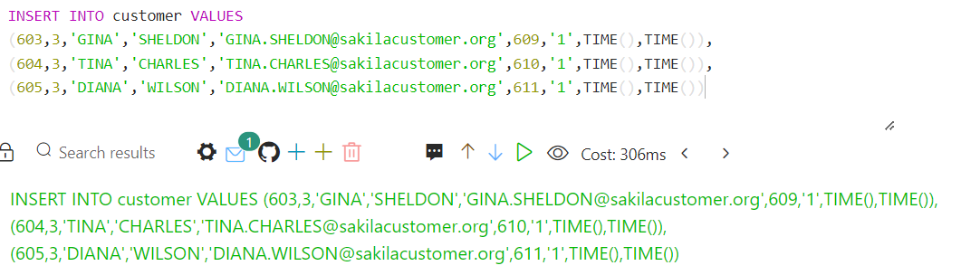

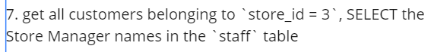

**SQL QUERY**

SELECT customer.*, staff.first_name,staff.last_name FROM customer JOIN staff

WHERE customer.store_id = staff.store_id and customer.store_id = 3

